צילומי מסך – Hands-On 6 :

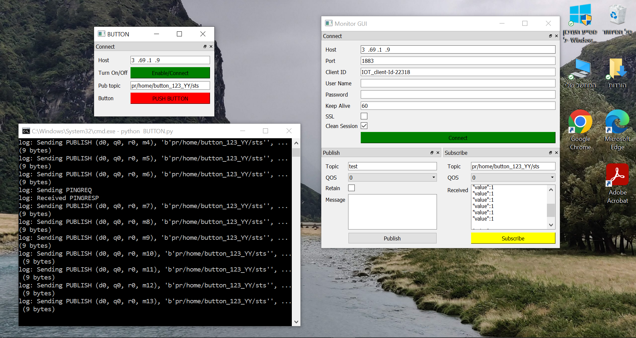BUTTON – Monitor GUI connection:

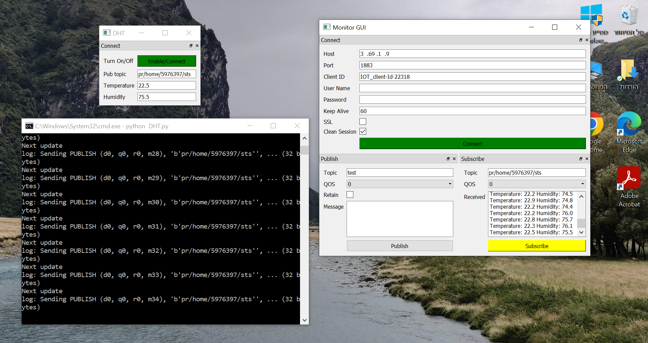DHT – Monitor GUI connection:

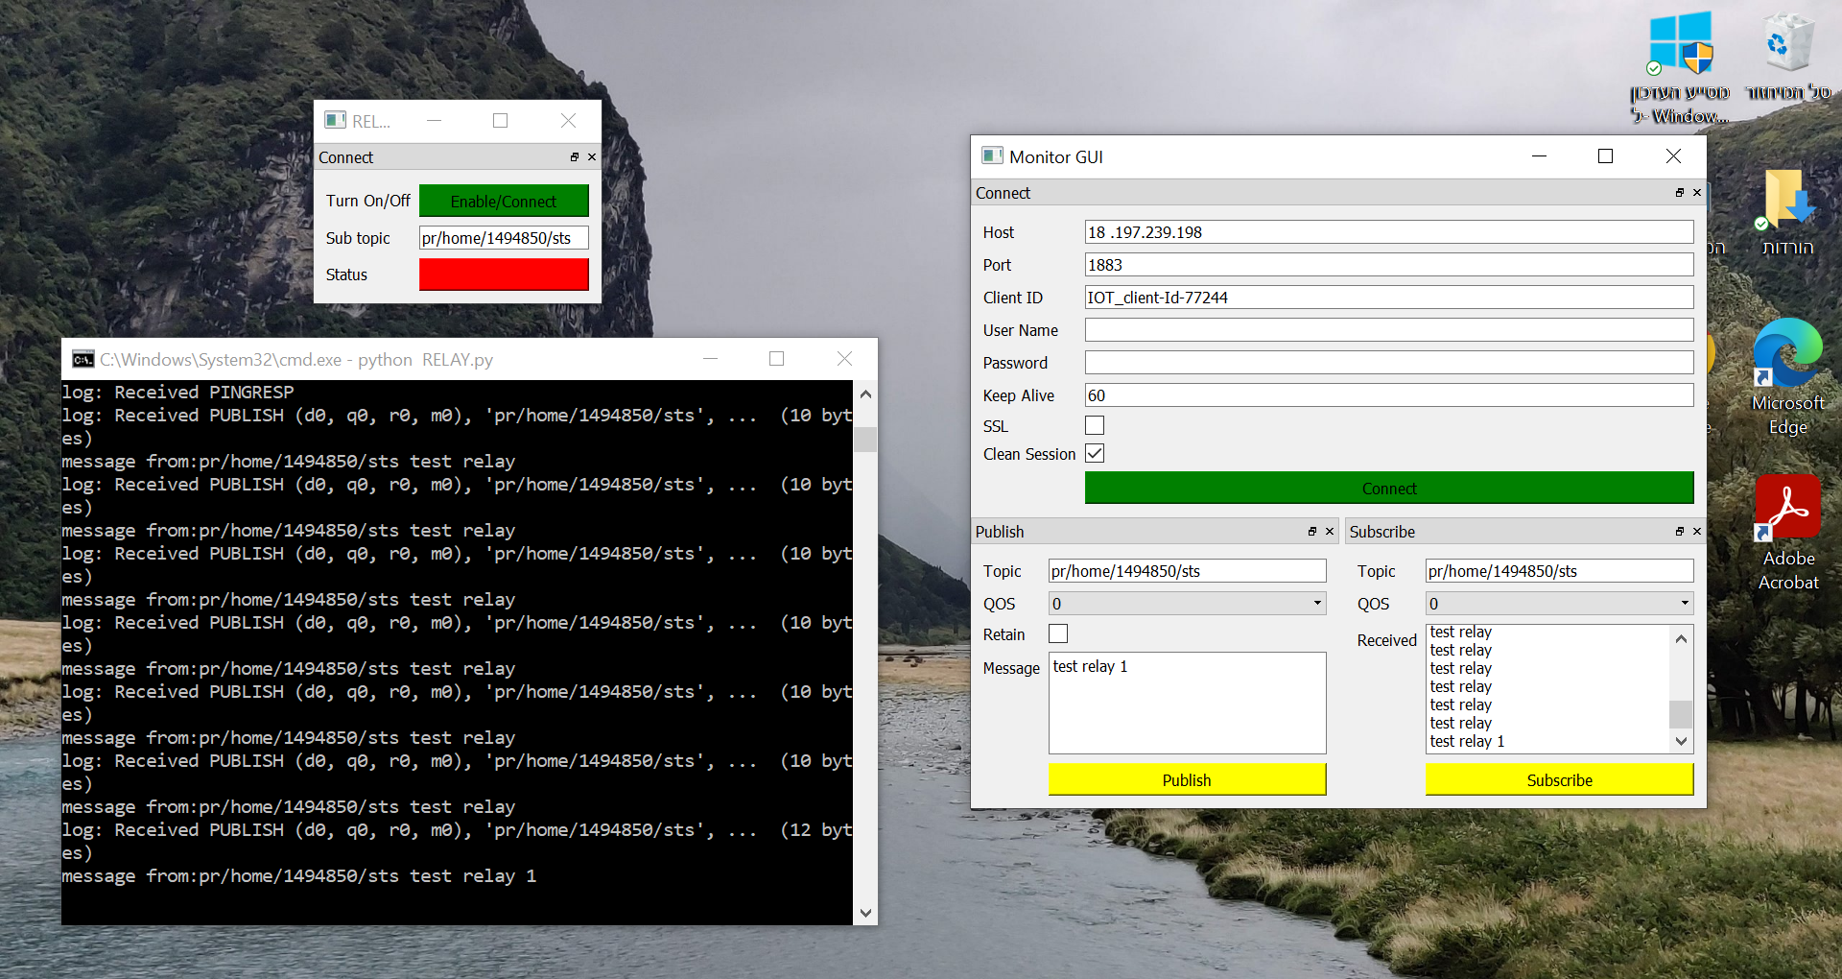RELAY – Monitor GUI connection:

